Multithreading – Thread Parameter passing and Return Handling assignments

Mandatory

- Create a multithreaded program to
- read 3 lines as a single command line argument
- extract every line and pass it to a thread.
- each thread should sort all the words in the line in ascending order and return sorted line to the main thread
- main thread to wait for all child threads to complete, then read and display the sorted line ”.
- Release any allocated memory
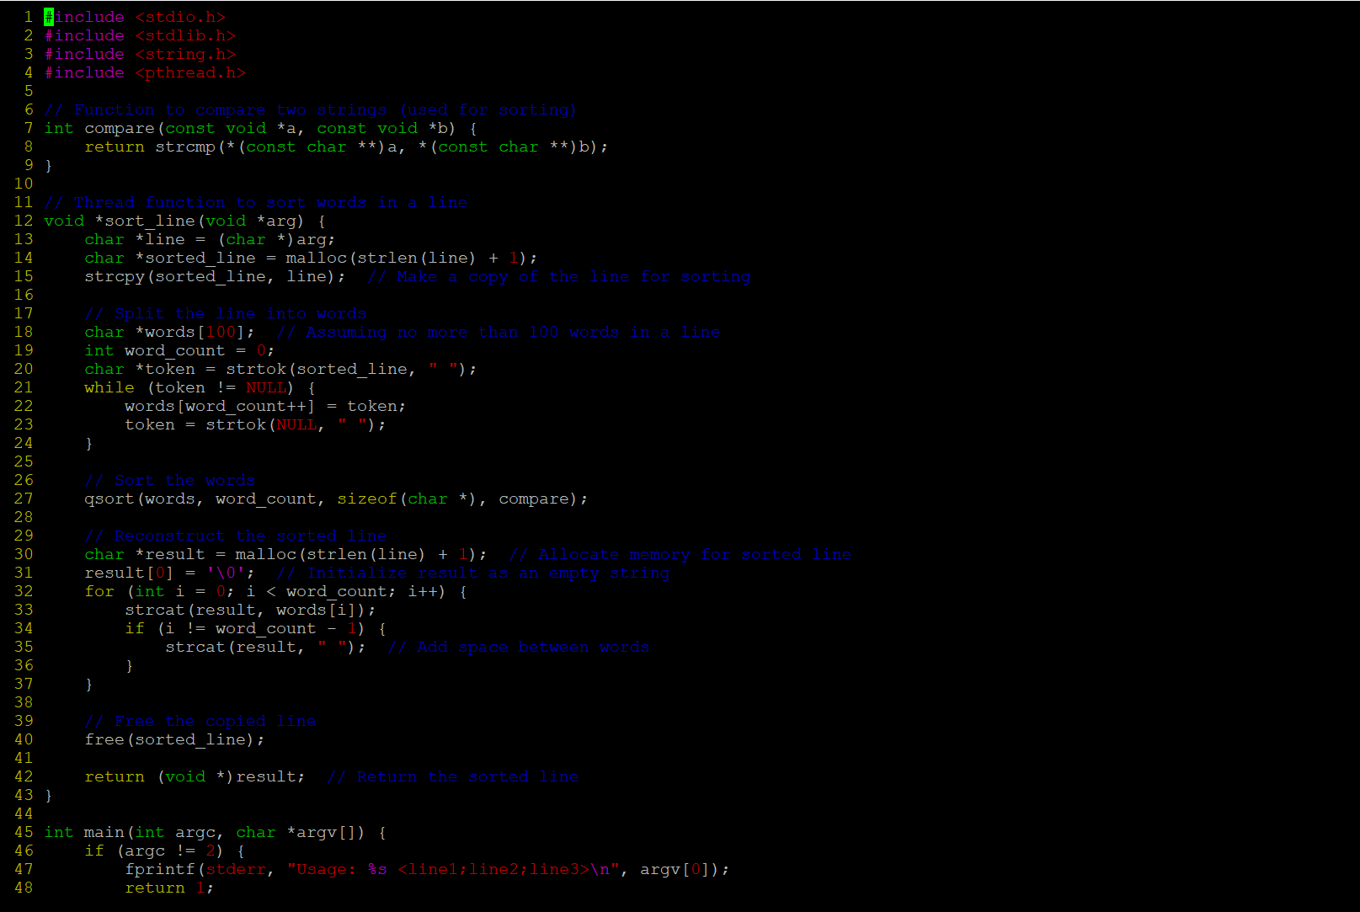
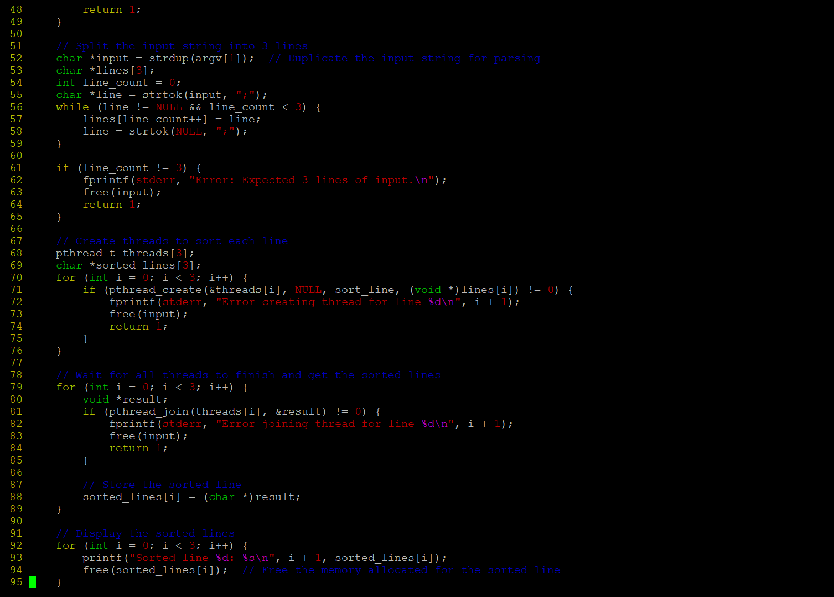
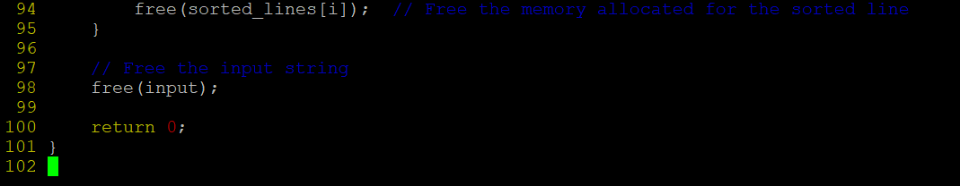
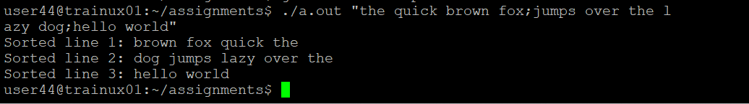

- Write a program to read a file name, to read lines , process it using two or more threads (i.e one thread/line) to count and display the words in the line. For this implement functions below, integrate and test solution.

//receive thread count as argument, create an array of pthread_t (double pointer allocated memory in heap) and return pointer
a) createthreads()

//to receive filename, thread array as args, process each line using a thread function
b) process_file()

//receive a line as input, count words and display, return line and word count to parent thread in a structure
c) thread_proc()

Ensure that there are no memory leaks
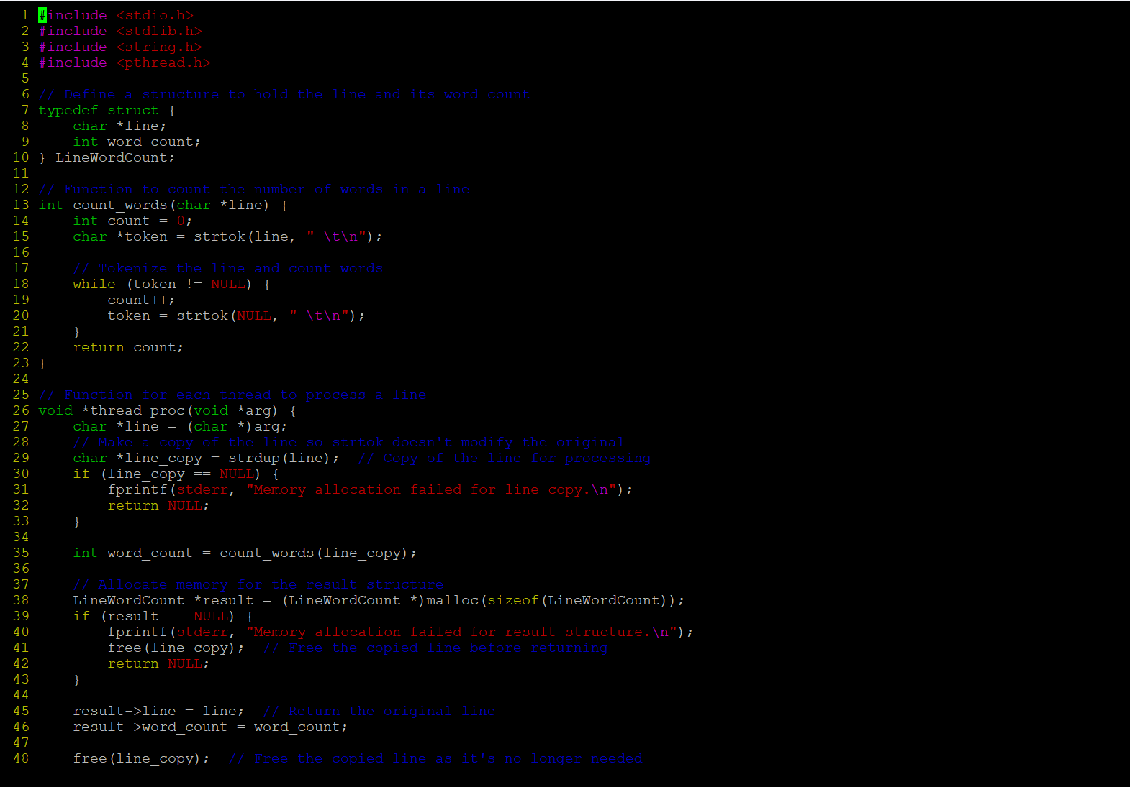
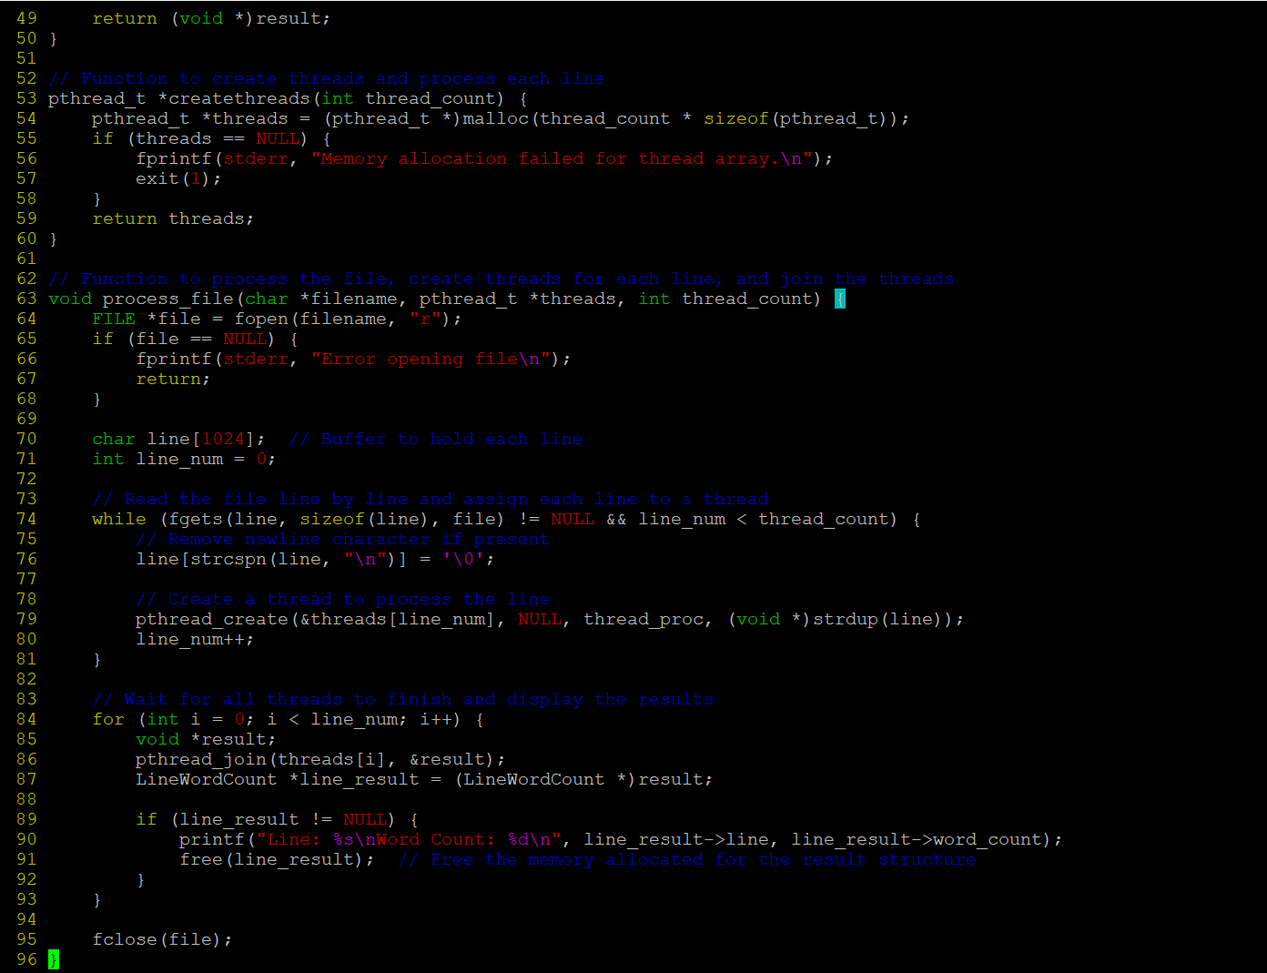

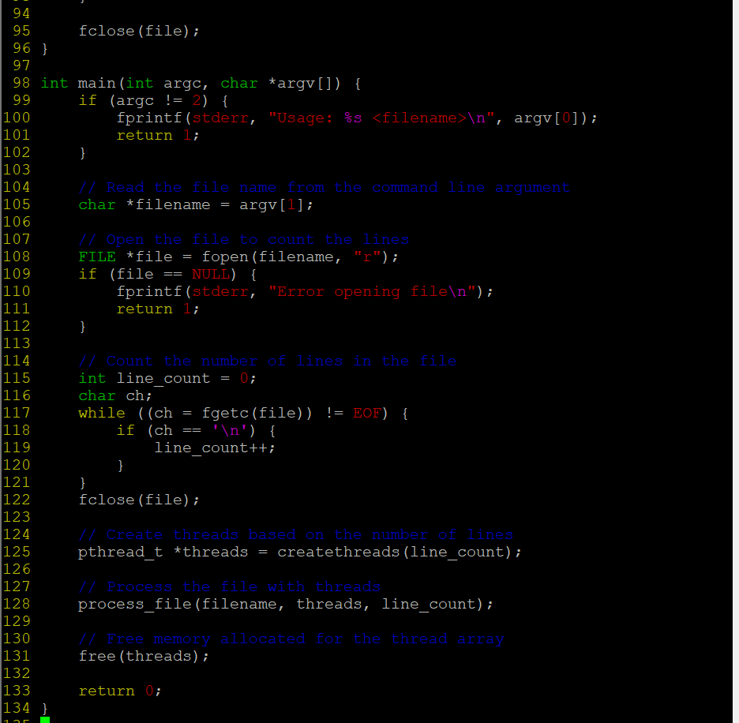
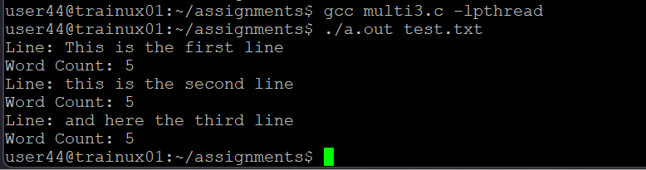
- In github or from other source, check for thread program related source code , download and test it, place the code and test cases executed with outputs. Understand , should be able to do a walkthrough in next session.

